Prologue
As the secretary-treasurer of FJUS, the US class association for the International FJ sailboats, I felt an obligation to attend the National Championship regatta that was planned for August 14-17 at Carter Lake in Colorado. Carter Lake is located just west of Loveland, about an hour north of Denver. Since we would have to trailer a boat and not taking the kids was not an option, I thought that renting an RV would be the best way to go. FJUS had planned a mid-week regatta so that people could take some time getting to the regatta and only take one week off from work. This would give us the opportunity to take our first extended family-only vacation, plus see a part of the country that we had only flown over before. Renting an RV would allow us to not have every meal in a restaurant and to prevent the trauma of having left something of great importance in a hotel room. So in the spring, we began to plan our big adventure.
We made arrangements to rent an RV, take time off from work, and planned our route. Reservations were made at RV parks along the way. Our original plan was to try and drive either early in the morning or in the late afternoon/evening and visit places during the day, however, the distances between the places we wanted to see dictated the driving schedule more than we would have preferred.
Plans were made, changed, and then never implemented up until the day we planned to leave.

Day 0 – Thursday – 10 August

The adventure begins…
With Jessica at summer camp and Jennica at a nearby daycare center (rather than her usual daycare near Jill’s office), the plan was for Jill and I to spend a calm morning doing a few errands and chores such as food shopping, getting the laundry done, and picking up the house. The RV rental office was a half-hour drive and the RV could be picked up anytime between 1 and 3 pm and we knew that it would take an hour or so to complete all the forms. We had optimistically called the rental company and asked if we could pick the RV up at noon, which they agreed to do. This would not be the last time on the trip that things did not go quite as planned. Instead of a leisurely morning, we had the normal mad dash to try and get everything ready.
Our boat was no where near ready to be used. It was still sitting on the garage floor, stripped bare, waiting for me to replace the centerboard trunk supports. I had bought a piece of marine plywood to do this, but that was all I had done the whole summer. I had already picked up the boat that we were going to sail from the McCutchens, who gracefully allowed us to use their boat. It’s good to have friends like them!
We arrived at the rental office at about 1 pm and proceeded to go through the process of promising our first born in the event that any damage befall their precious RV. After signing reams of paper the rental company gives a short orientation on how everything works and what to do when. In general, don’t fix anything, just call them. Despite many years of being on boats somehow this seemed much different while being the same.
After a short lunch at In-N-Out Burger, we returned home to begin the task of packing. By this time we had also picked up Jessica from camp and allowed her to pick out her special places, where she would keep her books, CDs, and videos. Packing proceeded in a fairly haphazard but somewhat coherent way, Jill would bring things from the house and I would find a place to stow them or question if we really needed to bring that particular item. Late in the evening we finally gave up and surrendered to the idea that we would not be leaving early in the morning, that there were still things that had to be done.

Day 1 – Friday – 11 August
Jill and I woke up early to try and get the rest of the things packed and ready as quickly as possible. We stopped trying to find a rational place to put things and just found an empty spot. The main task that I had to do was figure out how to get the round six plug light connector on the boat trailer to attach to the flat four plug connector on the RV. Fortunately, I was not the only person to have this problem and the local U-Haul dealer sold me an adapter that worked perfectly.
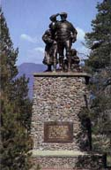
With everything finally loaded and ready, we let Fremont at about 10am, three hours past our original planned departure time. What ever we had forgotten could be replaced. A main difference between this and offshore sailing: there are 7-11’s and Wal –Marts along the way. We would arrive at Carter Lake about three hours after our original planned arrival time. (Ha!)

Pioneer Monument
At 22 feet, the base of the statue is at the height of the 1846-47 winter snow level
Driving along I80, our first planned stop was the Donner Memorial State Park at Donner Summit, about 35 miles before the California/Nevada border. Jessica had spent time studying the pioneers during the previous school year, so we felt as parents, it was our duty to reinforce what she had learned. We arrived at the museum at about 1pm, had a quick lunch in the RV and took a look around. The museum told the story of the hardships that the pioneers had in crossing the Sierra Nevada Mountain range, typically, during the beginning of the winter season. It also covered the infamous ‘Donner Party’ and their struggle for survival. The winter that they tried to cross the mountains was one of the worst in recorded history and the group had to break up into smaller groups. Those that survived did so barely and some were reported to have resorted to cannibalism to survive. The Pioneer Monument has a base that is 22 feet high which was the snow level that winter.
After a couple of hours at the park and museum, we took to the road again and continued east, crossing into Nevada, past Reno, and arriving in Wells around 9pm for our first night in the RV.

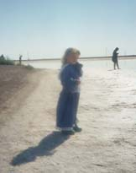
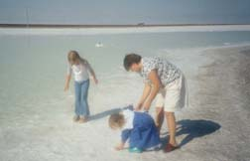
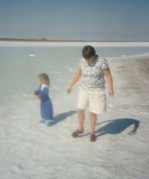
Day 2 – Saturday – 12 August
At the Salt Flats
Harvested salt became one of our first souvenirs. Jennica was very upset that she was not allowed to put on her bathing suit and go swimming.
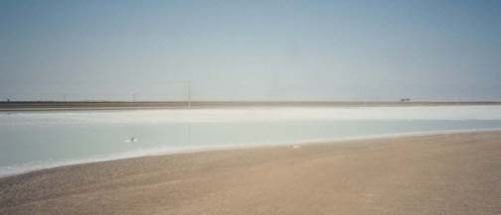
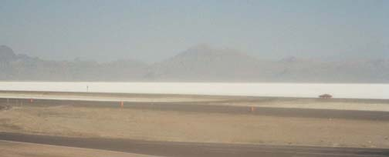
We woke up early, determined to leave early and to make up some lost time. Our goal for the day was to get to Jensen, UT with an early stop at the salt flats at the Nevada/Utah border and a late stop at Vernal, UT. We left Wells at about 7am and reached the border about an hour later. The road bed is elevated about 4 feet above the level of the salt flats (when they are dry) and ponds (when they are wet). There is a convenient rest stop where you can stop and walk out onto the flats or to the edge of a pond. We spent about a half hour walking around and taking in the salt and sites. The view can only be compared to looking at a huge snow covered field, everything is white and blue-white as far as you can see, until your eyes reach the mountains in the distance.
Views of the Salt Flats
Above Looking north across the highway – the Bonneville Salt Flats are off to the right of this view.
Below Looking south
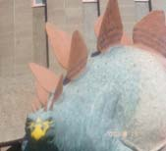
If you look at a map of Utah, I80 appears to be a straight line. It is, in fact, a 77 mile straight line cutting through the salt flats with absolutely nothing else around. No buildings, no gas, no food, just road and salt.
After passing through Salt Lake City we switched from I80 to US 40. While not an interstate, US 40 would take us to the parks and sites that we were interested in seeing. We stopped at the town square park in Heber City, UT for lunch. Heber City appeared to be a ‘Norman Rockwell’ type of town. We stopped at a great city park which was surrounded by the town hall and the police and fire stations. Like almost all the places we passed through after leaving California, the population was less than the elevation. This gave the girls a chance to run around and let loose a bit of energy.
After lunch we continued along US 40 to Vernal, UT which is about 35 miles west of the Utah/Colorado border arriving at about 4pm. Vernal is at the crossroads of US 191 and US 40.
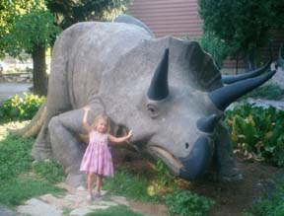
Our first stop was the Utah Field House of Natural History. This museum is dedicated primarily to dinosaurs although they had a display of luminescent rocks that the girls loved. They have a small area outside the building with a number of dinosaur sculptures. It was interesting that they did not paint the dinosaurs green but used a variety of colors to highlight the fact that we really don’t know what color the dinosaurs were.
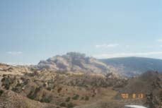
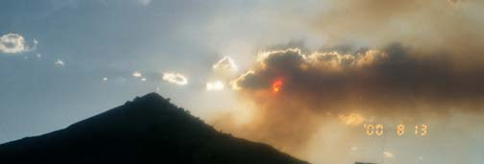
After leaving the museum, we took about a half-hour detour on US 191. Had we continued north about 45 miles into Wyoming, we would have reached the Flaming Gorge National Recreation Area. While we did not go that far north, we drove through what is called the ‘Drive Through Time’ on our way to the Red Fleet Rocks. As a result of all the geologic upheaval over millions of years, the land has become wrinkled like bedcovers after the kids have been jumping on them all afternoon. With erosion and road building, the layers of millenniums of ground creation have been exposed. This is a feature that we saw over and over, very distinct lines of earth types, with all sorts of colors defining the different layers. As you drive along, road signs are posted that let you know which era you are passing through. Red Fleet Rocks are a set of three rock formations that look like cargo ships that are beached on the sand. The evening light makes the ‘hulls’ look red against the sandy beach. After spending a few minutes absorbing the scenery, we returned to US 40 and continued east 22 miles to Jensen which is located at the west entrance to the Dinosaur National Monument park. It was lucky that we chose the scenic route as I80 was closed due to the forest fires – we could see them in the distance.
View along the Drive Through Time
You can see a bit of the geographic lines and colors in the hills.

Day 3 – Sunday – 13 August
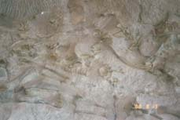
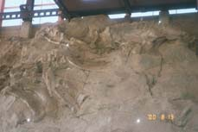
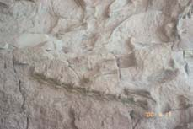
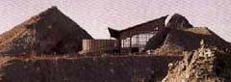
This was the first day that our original plan of being at our location when we woke up was realized. A short drive from Jensen, following the Green River, took us into the Dinosaur National Monument park. We only had time to see a very small part of the park, but what we saw was amazing.
Portions of Dinosaur Wall
The archeologists have stopped excavating this wall and moved onto greener pastures. The wall is located on the right hand side of the visitors building.
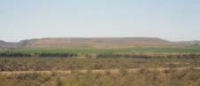
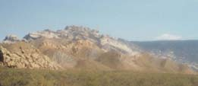
A short tram ride took us to the Dinosaur Quarry, our first stop in the park. This area is rich with complete dinosaur fossils, rich to the point where complete fossils were simply laying on the ground when the area was first discovered. The highlight of the area is a wall of dinosaur bones that is about 50 feet high and 150 feet long that is literally covered with dinosaur skeletons, not simply bones, but entire skeletons. The bones are on a wall as the geologic movement has changed the layer from a horizontal creek bed to a nearly vertical wall.
Green River Plain
This is a view from the Dinosaur Quarry Center. The flat topped mountains were typical of this area.
Green River Valley
A view towards the mountains. Note the lines of color running along the length of the mountain.
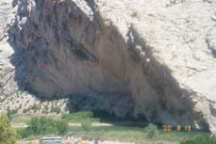
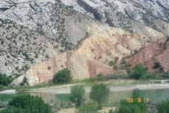
After returning to the RV we continued along the southern edge of the park, following the Green River and the park’s auto tour. We were fast becoming accustomed to the incredible views but even so, every turn in the road was a ‘Kodak moment’. Our first stop was the ‘swelter shelter’ a small cave that was used by humans as a resting place, possibly as early as 7,000 BC. The walls were adorned with both pictographs (paintings) and petroglyphs (etchings) from the Fremont Culture about 1,000 years ago. For lunch, we choose a spot near a bend in the Green River that is used by rafting companies as a haul out spot. We made a mental note that we would have to take the girls on a rafting trip here in a few years when Jennica is a bit older and able to handle herself in a raft.
Green River
Our lunch spot.
A bend in the Green River
Note the lines of color indicating different layers of rock. Also the trees only grow in some of the layers.
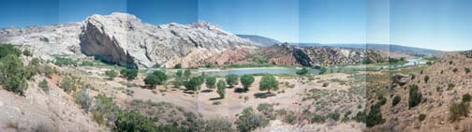
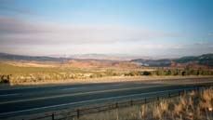
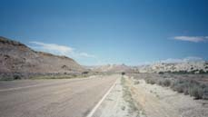
View from Rim above the Green River
This is a composite view of the Green River covering almost 180 degrees.
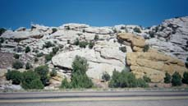
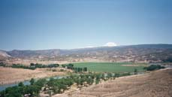
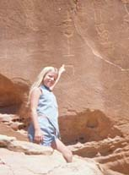
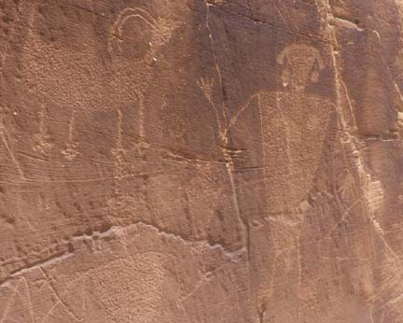
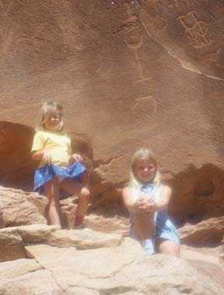
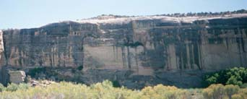
After lunch, we continued on the southern edge of the park heading towards Josie Morris’ Cabin. More beautiful views and petroglyphs were visual treats along the way. Some of the petroglyphs were etched into the rock itself and others were created by etching into the ‘desert varnish’, a natural black varnish like coating on some of the rocks. Unfortunately, we also saw signs of people’s complete lack of respect for the park and other people. There were those that felt that it was their right to add their own ‘petroglyphs’ to the site by carving graffiti into the rocks.
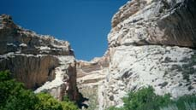
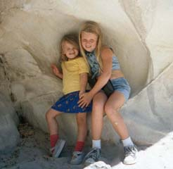
The Josie Morris cabin is the remains of the homestead of, of all people, Josie Morris. Josie Morris came to the Green River area in about 1915 when she was about 40 years old. By herself, she built the cabin and then lived there for nearly 50 years; growing food in fields that she cleared by hand, hunting for wild game, and keeping livestock in two nearby box canyons. For the city-folk, a box canyon is a closed, three walled canyon. Josie simply put a fence across the open end. When Josie died in 1964, her land became a part of the park.
Josie Morris’ Box Canyon
View looking up into the box canyon. The walls formed three sides of the livestock pen.

Jessica and Jennica
The girls are sitting in a small hollow in the wall of the box canyon, formed by water running down from the plain above.
From the Morris cabin we backtracked through the park and rejoined US 40 at about 3pm. Heading east once more, we drove the 140 miles to Steamboat Springs. After such a full day we decided it was time to pick up a few supplies at the grocery store and have pizza from Round Table for dinner.
This was our first night at a KOA campground. The RV parks that we had stayed in thus far were pretty simple affairs. They had gravel driveways with drive-through parking spots for the larger RVs with hookups for electricity, water, and sewage. Adjacent to the driveway would be a picnic table and a grill. Most also had a building which contained showers and toilets for general use. Some had connections for cable TV and a small shop for essentials, but not much else. For those who are not familiar with RVs and their waste water systems, the RV had two waste water tanks, one for grey water and one for black water. Grey water is water that goes down the sink or shower and black water is water (and other things) that go down the toilet. The tanks have a pipes that connect via a “Y” connector and a common drain hose is connected to the leg of the “Y”. The drain hose is then dropped into a ground level pipe that connects to the local sewer system. Each pipe has a valve just before the connection to the to a common hose so that each tank can be emptied separately.
If the places that we were had stayed in to date were ‘Red Roof Inns’, then the KOA campground was a ‘Hilton’. They had a pool, full convenience store, bicycles, putt-putt golf, computer hookup, etc. for the general use. After the kids had settled down for the evening, Jill and I tried to be good workers and retrieve our e-mail using the computer hookup. What we were thinking, I don’t know, but we were not able to get it to work, so we remained blissfully ignorant of what was happening in the real world.

Day 4 – Monday – 14 August
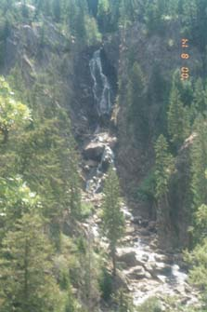
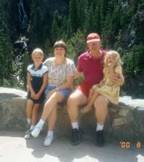
Realizing that we had only a short distance left to get to Carter Lake, we didn’t push hard to leave early. We took long hot showers and headed off to see Fish Creek Falls, a 283 foot waterfall before hitting the highway. A short walk down a dirt trail took us to the viewing area where we could see the full length of the falls. We could tell that during the spring run-off the falls would be spectacular, but in mid-August without the full volume of water they were a bit disappointing.
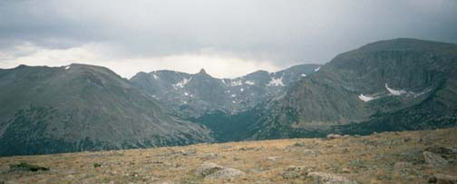
Shortly after 10am we hit the road again. Steamboat Springs is at 6,700 feet above sea level. Our route on US 40 took us through Rabbit Ears Pass which has an elevation of 9,426 feet. The main thing that we looked for going over the pass was snow. The girls see snow only once or twice a year and the idea of seeing snow in the summer was amazing. This was only the beginning of our ascent. We turned off US 40 and got on US 34 which would take us through the Rocky Mountain National Park. Our final destination just on the other side of the park.
View of the Rocky Mountains
Looking out over the Rockies. The trees don’t go to the top of the mountains. Above the tree-line the ground doesn’t thaw enough for the trees to take root.
Soon after entering the park, at 8,720 feet, we saw something that we would see a number of times on the west side of the mountains. Cars were lined up for a quarter mile on both sides of the road. Everyone had stopped to view a herd of elk that were grazing in a field. Our first stop in the park was the Alpine Visitors Center which was located at 11,796 feet above sea level. The girls did not seem to be effected by the altitude, but it sure made it difficult for me to carry Jennica around! After checking out the highest gift shop in the United States, we loaded back into the RV to continue our climb to the peak. This road is only open from mid-June through the end of September. Driving slowly, due to the brisk cross winds, we reached the peak at 12,183 feet and began our descent to the park exit at 8,240 feet. If we had realized how magnificent the park was, we would have made an earlier start rather than viewing the falls.
After exiting the park, we drove following the Fall River through the town of Estes Park. The town and road are located at the bottom of a very deep canyon created by the river. In some places the canyon was no more than 150-200 feet wide, just enough room for the road, river, and one house. It seemed as though if the river rose, the entire town would be swept down the canyon. Based on the style of house, it seemed that the town was a summer vacation spot for fishing and as a station for hikers going into the park.
Our main goal in Estes Park was to find a copy shop where I could make copies of the Sailing Instructions and materials for the class meeting that was scheduled for that evening. We found a Mail Boxes Etc. where I could do some copying and the girls took the opportunity to do some additional food shopping to restock the larder.
From there, the landscape leveled out into a plateau and we proceeded along easily and quickly since we were a bit behind our target arrival time. The plateau is the same one that the city of Denver is on. However, we were no longer impressed with the idea of the ‘Mile-High City’ since we had driven down 7,000 feet that day to get there and we had been at or above that height since leaving California.
We arrived at Carter Lake at about 5pm in the afternoon, 3 hours later than we had originally planned and almost the exact delay that we had leaving four days earlier. We could see the other FJs returning to the dock from the practice race as we drove into the camping area. There was no one at the club house, so we went down to the docks and greeted the boats as they returned.
Our original plans had us, and the other out-of-towners, staying at a nearby commercial RV park/camp site. However, this was about 20 minutes away from the park and did not appear to be very appealing. The others who had come from the east had arrived on Sunday and decided to camp right at the lake and were allowed to group everyone into a single campsite. We had been cleared to park the RV in the site’s parking space so we canceled our reservation and joined the rest of the group. The only down side to this arrangement was that there were no hookups (water, electricity, or sewage) for the RV, so, to the detriment of the solitude, we had to run the generator more than we would have liked and rather than fill the grey water tank we took “baths”, in the lake.
The evening plans were a dinner sponsored by the Carter Lake Sailing Club followed by the national class meeting. The club members proved themselves to be very friendly and congenial hosts, something that would be repeated often during the regatta.

Day 5 – Tuesday – 15 August
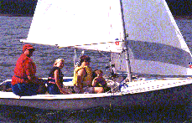
As there was a tremendous amount of work to get everything ready for the racing, I woke up early and proceeded to unload the boat and begin to rig everything.
Carter Lake is a man-made lake formed by damming three canyons and is primarily a storage facility for drinking water. The lake is about 2 miles wide by 7 miles long and nearly 200 feet deep. The lake is fed with 34 degree water via a pipeline which enters the lake near the bottom. The slight upwelling and greater than freezing temperature mean that the lake is one of the few things that doesn’t freeze in the winter and they run an active frostbiting series in the winter. The Carter Lake Sailing Club maintains a set of floating docks and have boats up to about 30 feet. Additionally, the lake is used for fishing and water-skiing although neither of these activities bothered us during the regatta. The club house sits high up on the hill and the boats are ramp launched. During our regatta, the lake level was about 20 feet below the normal level but this in no way detracted from the event.
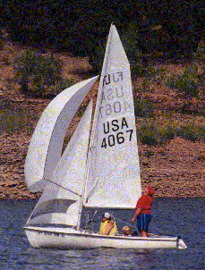
Our original plan was that Jill and I would be sailing and Jessica and Jennica would have a babysitter. As things turned out, the girls wanted to sail with us and the babysitter canceled at the last minute. This turned the regatta into a family affair which was great.
After a short skippers meeting, we launched the boats and sailed out to the starting area. The wind started light and there was a delay while we waited for the breeze to fill. Since we had never practiced with four people (we also hadn’t practiced with just Jill and I either!), this gave us a chance to practice a few tacks and figure out how to have everyone move around.
Once the wind filled in, we began the racing. Jessica was our timekeeper and Jill and Jennica trimmed the jib. I trimmed the main and steered. We had a good position shortly before the start of the first race, but were not aggressive enough and let the eventual winning and second place boats off the hook. Our tactics were to sail simply, in clean air, and hope we picked the right corner. At first, things seemed to be working out and we crossed ahead of one or two boats. At the second crossing, we were behind those boats and Jennica turned to me and said “Daddy, you did that wrong!”. Despite that we continued to have a good day and the weather was beautiful. We managed to finish ahead of at least one boat in each race so after four races we felt pretty good about our performance. At that point, the race committee called off racing for the day and we headed back to the dock where we spent a fun hour swimming at the end of the ramp and jumping into the water while other people pulled their boats from the water.
We had a quiet family dinner and spent the evening talking with the other sailors, swapping greatly exaggerated stories. Earlier in the day we had told Jennica that you should always leave a camp site cleaner than you found it. She took this to heart and used the broom from the RV to sweep off all the rocks in the campsite and then prohibited anyone from sitting or walking on the rocks and making them dirty.

Day 6 – Wednesday – 16 August
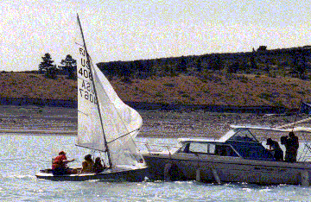
The second day of racing began under threatening skies. Thus far we had been lucky and we had not been forced to modify our plans based on the weather. We could hear thunder in the distance and I hoped that we would have a good old fashioned thunder and lightening storm; just after the racing (about the only weather phenomena that I miss living in California is a proper thunderstorm).
Again we were racing as a family, and managed to put together a couple of good windward legs. Once the racing had begun we could tell that the race committee was also watching the weather and we watched two or three storm clouds skirt along the edge of the lake. This gave us the best wind conditions of the regatta and the girl’s fear of the weather turned into squeals of delight as we zoomed along while they dragged their hands and feet in the water to verify just how fast we were going.
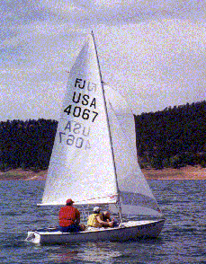
We completed three races before the race committee decided that we had pressed our luck with the weather long enough and sent everyone back to shore. With 7 of 9 races in the books, they also wanted to leave some racing for the last day. At this point Paul Hemker had sewn up the regatta with an impressive collection of races. Duncan Shaeffer gave him a good run but Paul managed to just get enough out of his boat and crew to hold on. We had our best race of the regatta finishing fourth in the last race of the day.
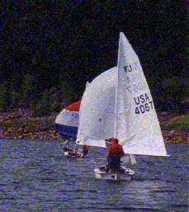
Returning to the dock, we again spent time playing in the water. Jennica loved bouncing around in her life jacket and being tossed in the air. Jessica enjoyed jumping into the deeper water and running around and doing it again.
Once everything was put away, we drove the RV around the lake to the RV dump station and empty the holding tanks. We also took the opportunity to take hot showers without the worry of over-filling the grey water tank. Having invited the others to join us for dinner rather than have them cook in the rain, we made a trip to the grocery store in town. The club opened up their club house and kitchen to us and, as a group, we cooked a huge batch of spaghetti and tortellini. This was accompanied by salad and bread for a wonderful meal. After dinner and desert, the young kids (we had four kids in the 10-15 year old range) played cards while the adults talked. Jennica, inspired by the Latin music, gave a dance recital and had me join her. While I did my best, Jennica spent time helping by telling me what moves to do next. After she became tired of dancing, we spent a short bit of time talking about boats and even had a short rules quiz. As we drove the RV back down to the campsite after dinner we were treated to the site of a couple of foxes nosing around the campsite. They did not seem afraid of us but after a few minutes decided to move on.
We went to bed late and tired, but having had a truly wonderful day.

Day 7 – Thursday – 17 August
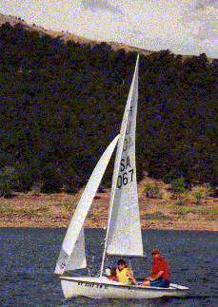
Today would be the last day of the regatta and our last at Carter Lake. The race committee planned for two longer races plus a fun race. Under cloudy skies, but initially without the threat of rain, we sailed in the lightest air of the regatta, and we had our worst races in terms of results. Given that we had a fair amount of packing to do and the skies were becoming more threatening, we decided to skip the fun race and head back to the dock. As we approached the dock, Jill tried to jump in the water and hold the boat. What she discovered though was that the ramp was much steeper than she thought and she wound up in water over her head much to her surprise and delight of the girls. While I was swimming from the dock with the girls, Jill, using Mike Wyatt’s van, pulled the boat from the water and drove it over to the parking lot. Unfortunately, she did not notice the overhanging branch of one of the trees and knocked the mast down. This caused far more embarrassment than actual damage, breaking only the safety loop on the forestay.
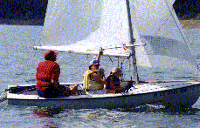
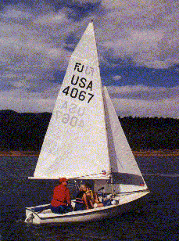
With our swim done, I began the process of packing everything back up for the drive home. By then the threat of rain had turned into a short shower and things went back into the boat a bit wet. Jessica and Jennica proved to be a great help to the other campers when it began rain. They ran around and took the clothes off the line and put them in the ‘appropriate’ tents. Jessica had a good idea what should go where. Jennica put things where her logic told her they belonged. This amounted to making sure that things were evenly distributed among the tents and that no tent was ‘lonely’ for wet clothes.
All that was left to do now was to have the trophy dinner. After cleaning ourselves up a little bit, we headed up to the club house to award the trophies and hold the silent auction. Dinner was a pig roast with all the trimmings. While everyone did their best to eat what was available, we divided up the leftovers among anyone who would take any. Our portion lasted until mid-September!

Day 8 – Friday – 18 August
We got up very early and helped some of the other sailors finish their last bits of packing. While we knew that we should hit the road, we did not want to leave our new friends until we absolutely had to. We finally left about 7am and drove east on US 34, connected to I25 south, and, finally, turned onto I70 west. Our destination was Moab, UT and Arches National Park about 400 miles away. Starting in Gypsum, CO, about 100 miles from Denver, I70 follows the Colorado River and we were often in the canyon carved out by the river. We could see people rafting and fishing in the river and we renewed our desire to take a rafting trip with the girls.
Things were going along smoothly and we were actually on schedule when we felt the back of the RV start to bounce up and down rhythmically. We had just passed into Utah but there was not a building, hut, or house to be seen in any direction. At first I thought that it was just bumps in the road but when changing speeds did not change the rhythm I became a bit more concerned. We pulled off to the side of the road and I made an brief inspection of the RV paying close attention to the tires. There was nothing that I could see so we started back up again. Moments after getting back up to speed we heard a large bang followed by the sounds of rubber flying everywhere. This time the problem was very easy to find. The RV had dual rear wheels and the inner right rear tire had exploded. While the RV had a spare tire, we had been instructed by the rental company to not attempt to change a tire. This point was reinforced by the fact that they provided no jack or tire iron. Since we were truly in the middle of nowhere and could not get a cellular phone signal, we decided that we would continue on to the next exit which was only about 20 miles away. With Jill watching the cell phone signal strength markers and calling out the number of signal bars (0 to 4), we continued along the highway at a much reduced pace, not wanting to put too much stress on the remaining right rear tire. When we reached the first exit, we found that it was nothing more than where two roads crossed, with a place to fill up on gas. We decided that since we had gotten that far, we would simply continue on and see what happens, after all that was simply a part of the adventure. We finally got a strong enough cell phone signal we stopped and called the rental company. They told us that we were doing the right thing and to find a tire shop, have the tire replaced, and they would reimburse us. The next two exits were the same as the first. The fourth exit had a gas station and convenience store, but no mechanic. It turned out that the nearest place that could take care of our problem was 5 miles past our destination, which was still 50 miles away! At Crescent Junction, we turned south on US 191 towards Moab. We plodded along slowly and at about 6pm reached the RV park in Moab, UT just outside the Arches National Park. Because of our slow pace, we arrived about a half hour too late to head into town and have the tire replaced that day. Fortunately, the tire store would be open on Sunday and we would be able to get a new tire then. When we reached the parking spot, I noticed that the “Y” connector had separated from the black water valve which would prevent us from draining both of the waste water tanks. As it was getting dark, I decided to attack the problem in the morning since we would have time before the tire store opened.

Day 9 – Saturday – 19 August
I woke up a bit early and took a quick shower and then proceeded to work on the drainage valve problem. Upon close examination, there was nothing actually broken. Each valve was constructed of three plates that were bolted together. The center section contained the actual valve and the left and right sections held the connecting pipes to the valve by a small flange on the connecting pipe. In this case, the PVC “Y” fitting had simply pulled free, perhaps from being hit by a piece of road debris. On the tank side of the valve, everything was intact. Connected to the valve was a short piece of PVC pipe which was connected to the actual tank outlet by a six inch piece of rubber tubing that was hose clamped to each pipe. My original plan was to simply muscle the “Y” back into the valve. It was, after all, a small flange. So sitting with my legs under the RV and the black water valves, I was trying to work the “Y” fitting back into the valve. With each unsuccessful attempt, I used a bit more force than the previous time. Suddenly, the valve and rubber hose pulled off the black water tank. Now I had real problems. I quickly clamped my hand across the open pipe to the black water tank to prevent the remainder of the tank from spilling onto me and the ground. I called for Jill to bring a bucket and we emptied the tank, one bucket at a time. Once the tank was empty I was able to get up out of the puddles and clean myself off a bit. With the valve now free of the tank, it was a simple matter to reconnect everything and begin the clean up process. I went and took a long hot shower and then hosed down the RV. I borrowed a shovel and took about ten bucketfuls of top soil to the dumpster to complete the clean up.
Black Water Tank
Grey Water Tank
Rubber Hose
Valves
With that problem solved, we turned our attention to getting the rear tire fixed. We had been told where the tire store was and who to talk to by the RV park attendant. A short ride took us into the heart of Moab where we found the tire store with no problems. While the tire was being replaced, we walked down the street and had breakfast at a local fru-fru breakfast café. While the younger girls were not impressed by 8 dollar pancakes, Jill was able to enjoy a special cup of ‘Jamaican Blue’ coffee. Thinking that the tire replacement would take longer than it actually did, we walked back slowly, window shopping and looking for new walking around shoes for me. We picked up the RV, found a shoe store that wasn’t charging $75 for a simple pair of shoes and headed south from town to find the Hole-N-The Rock house.
The Hole-N-The Rock was a diner and house that was carved out of the side of a rock formation. The diner was built out from the rock and the 5,000 square foot, 14 room home was carved into the rock by the owners. Starting in 1945, they spent the next 12 years carving 50,000 cubic feet of rock out the sandstone mountain. After a short tour of the home, we turned our sights to the Arches National Park located on the north side of town.
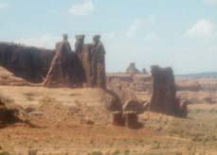
The Arches National Park is the home to many incredible rock formations created by thousands of years of erosion. Unfortunately with the delays of getting the tire replaced and so forth, we only had a few hours to check things out.
The Three Gossips
A monolith formation with balanced rocks.
With our limited time and threatening skies we decided to take the driving tour with a few short hikes. Arches National Park contains a number of different fascinating rock formations including fins, monoliths, and arches. A fin is a vertical slab of rock that was formed by the erosion of softer layers of the surrounding rock. A monolith is a rock formation or spire that has been separated from other nearby formations by erosion. The balanced rocks fit into this category. Arches are formed by the wind erosion of a fin creating a horizontal hole in the fin. In rare instances, a vertical hole is formed in a ledge.
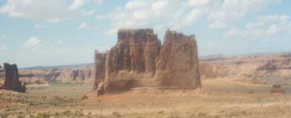
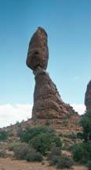
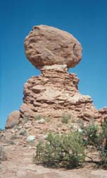
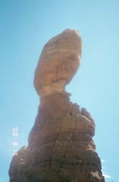
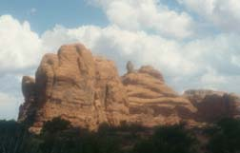
Our first stop was an overlook where we saw a number of monoliths and got an overview of the valley. There were arches visible in the distance but we would have to wait to see them up close.
Tower of Babel (left) and Organ (right)
These monoliths are the remains of fins that ran from left to right.
Balanced Rock
This formation is 128 feet high. The large bolder on top is 55 feet high and weighs about 3577 tons. Although it looks as if the rock is cemented to the pedestal, this is the natural color of the rock layer that is supporting the boulder.
Another Rock Formation
Note the balanced rock on the top of the formation.
We proceeded along the road to Balanced Rock. This type of monolith formation is not unique in the park and there were many other balanced rocks although none quite as dramatic.
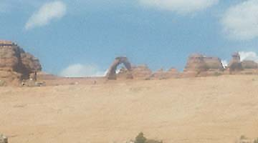
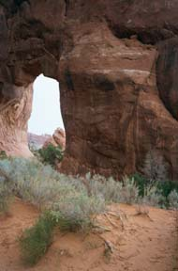
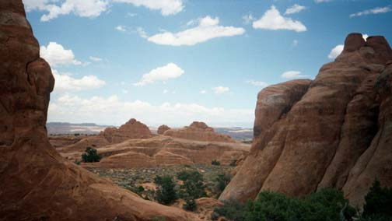
After a short drive, we came to the Devils Garden Trailhead that would take us to a number of arches. First we followed the main trail which took us to Landscape Arch. The sandy dirt trail was fairly easy to walk and started by passing through a set of fins that in some places were only a few feet apart. The only problem we encountered was that Jennica refused to walk, preferring to ride on Daddy’s shoulders. As we retraced our steps on the trail, it began to rain off and on. We took a side trail to see the Pine Tree and Tunnel Arches. As we returned to the RV, the rain came down harder, soaking all of us. We quickly changed clothes, had a snack and then headed for the park exit. Our goal was Salt Lake City and I80, about 250 miles to the north.
Delicate Arch (above) and Pine Tree Arch (right)
Delicate Arch (above) is an example of a mature arch. These are the oldest arches and are closest to collapsing. Arches continue to grow until the rock gets too thin and the arch collapses.
Pine Tree Arch is an example of an immature arch at ground level. These arches are just at the beginning of their ‘life’. The hole is much smaller than the surrounding rock. The hole will continue to grow due to wind erosion.
View from between fins
Looking down the Devils Garden Trail from between two fins.
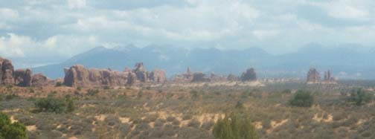
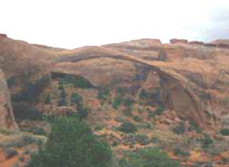
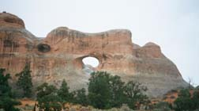
The trip north was uneventful and we reached Salt Lake City about 10pm, tired and ready for bed.
Landscape Arch (left) and Tunnel Arch (above)
Landscape Arch is a very mature arch. This is one of the world’s longest stone spans stretching 306 feet but is only about 11 feet thick in the center. The right hand edge was about 5 feet thicker until September 1991 when a 70 foot long slab suddenly broke free from the underside of the arch with only seconds of warning.
Tunnel Arch is very young arch, based on the relative amount of rock and size of hole. To the left and slightly above is a rare vertical arch. Water plays a much bigger part in creating these types of arches.
Devils Garden (below)
Scenic view of the Devils Garden. You can see some of the rock fins.

Day 10 – Sunday – 20 August
We had originally thought about taking US 50 across Nevada so that we would not be retracing our steps from the trip out but since our next destination was near the junction of I80 and US 50, we decided it would be faster to take I80. Since we had a long distance to go, I got up early and started down the highway. Our destination was the town of Fallon about 60 miles east of Reno in western Nevada and home to the Navy’s ‘Top Gun’ school. Jill had read in our guide books that there were some interesting sounding ghost town type sites in the area.
As we approached the Utah/Nevada border, we noticed that the refrigeration system had stopped working. We discovered this mostly because the ice cream in the freezer had melted and made a huge mess. After looking through the rental guide, we thought that perhaps we were running out of LP gas. Despite the fact that the gauge read half-full, we thought that there might not be enough pressure. A quick call to the rental company confirmed our thoughts. After crossing the salt flats, we stopped at the next exit on the highway, West Wendover NV, and went to the KOA campground to get LP. West Wendover is an interesting city. It is located just inside the Nevada/Utah border and is essentially a group of casinos for the people of Utah to escape the lack of alcohol and gambling in Utah. We got back on the road and watched to see if the refrigeration would respond to having more pressure. Unfortunately, this did not solve the problem, so we stopped again and purchased a cooler and ice.
We arrived in Fallon around 3pm ready to get out of the RV and do some walking around. Unfortunately, the guide books made things sound much more interesting then they turned out to be. Our first stop was a large sand dune/mountain called, oddly enough, Sand Mountain. The main claim to fame is that the mountain is one of the few ‘singing mountains’ in the country with the mountain letting out low moans as the sand shifts. The dune sits out by itself and was formed millions of years ago and covered up. Later erosion exposed the sand again creating the mountain. In the shadow of the dune was the remains of a Pony Express office. The walls were made from the volcanic rock that litters the valley. The immense hardships that the people faced were very evident since there was no natural source of water or food for miles. It was a truly desolate place to have a building and rest stop. Unfortunately, we couldn’t hear the moans due to the sand buggies being ridden all over the dunes.
Based on what we had seen thus far, we decided that we would rather press on to the South Lake Tahoe area and spend the night there rather than try to find a place in Fallon. Also, Jessica had been complaining for some time about the fact that we had never taken her to Lake Tahoe and that her life would not be complete until then. So around 6pm we left Fallon and headed west on US 50, through Carson City, heading toward Lake Tahoe.
This was the only night on the trip that we had not made reservations in an RV park prior to arriving. This meant that we had to do a bit of searching to find a spot for the night, which we finally did about 9pm.

Day 11 – Monday – 21 August
This was our last day of the trip and everyone was ready to be home. We knew that we would have to make it all the way home today. Our first stop was the South Lake Tahoe visitors center so that we could get some ideas of what to do. After looking through all the options, we decided to take a tram to the top of Heavenly Peak. Unfortunately, the day was very overcast and smoky from some of the nearby forest fires and we could see very little of the lake. At the peak, we went for a short hike and checked out the local geology.
After returning to lake level, we drove to a local park that had a very small beach so that the girls could go for a bit of a swim. In reality, the beach was a strip of sand about 5 feet up from the waters edge. The sand did not extend into the water and so walking into the water was both cold and hard on the feet. Jessica soon tired of being blue, but Jennica wanted to stay and play in the water since she did not have to touch the bottom using her float. We returned to the RV just after lunchtime and left for home.
The remainder of the drive was uneventful and we arrived home at about 6pm.
We started emptying the RV that evening, mostly just moving things from the RV to the house without really putting the things away in the house. We would have time for that after we returned the RV.

Day 12 – Tuesday – 22 August
After a good night’s sleep in our own beds, we awoke to the task of emptying and cleaning the RV. The RV was due to be returned to the rental center by 11am. We spent an hour or so making sure everything was clean and in its place and then took the RV back to the rental center arriving about 10:30. With that done, we returned home to complete putting everything away, sort the mail, check e-mail, and basically return to our normal lives.

Epilogue
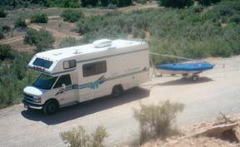
On the trip, we covered 3,065 in 12 days getting about 10 miles per gallon. We spent $2,500 to rent the 25 foot RV and for the extra mileage (2,000) over the 1,000 allowed. We spent about $600 for fuel and the RV parks averaged about $17 per night. All in all we spent about $3,500 on this vacation.
Would we do this again? Emphatically, yes. The trip was successful in so many different ways. We saw so many new and fascinating things each and every day that we almost became blasé about them. We had a great time at the regatta and made some great new friends. The girls returned home with an interest in sailing that was not there before.
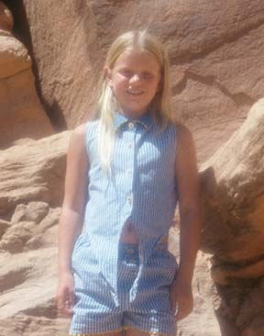
What would we do differently? Not much other than to spend more time in each place. Because of our overall schedule, we could do no more than get a bit of exposure to each place. If we did not have to tow a boat, we would opt to rent the RV in Salt Lake City and fly or drive there. If we drove, we would then tow the car with the RV so that we could use the RV as a base camp and use the car for excursions. We would then do a loop roughly following the Utah border.

